Software testing methodologies:
SDLC ( Software development life cycle) meaning: process of developing software. Each part of the cycle has entry and exit criteria along with deliverables. Order of steps:
- Requirements gathering
- Design
- Development
- Test
- Deploy
- Maintenance
STLC ( Software Testing life cycle) meaning: testing process of the SDLC. Purpose of this life cycle is testing and finding errors to ensure the product’s quality. Each part of the cycle has entry and exit criteria along with deliverables. Order of steps:
- Requirements analysis
- Test planning: is a blueprint for running tests to ensure that software is working as expected. Detailed documentation includes the testing scope, strategy, objectives, schedules, estimations, resources required, and deadlines for a project.
- Test case development
- Set up environment
- Test execution
- Test closure

Usecase: describe how a person using system/process will accomplish a goal. Help identify test cases to cover a system.
Types of testing I did before: black-box testing, functional testing (application testing and user acceptance testing) and regression testing .

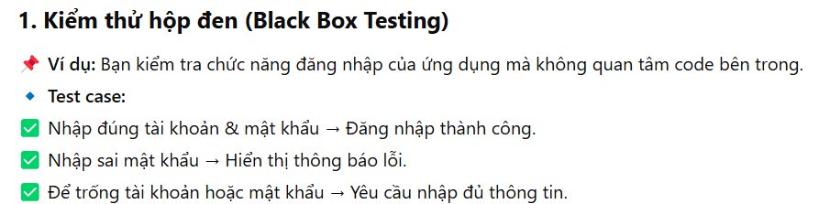
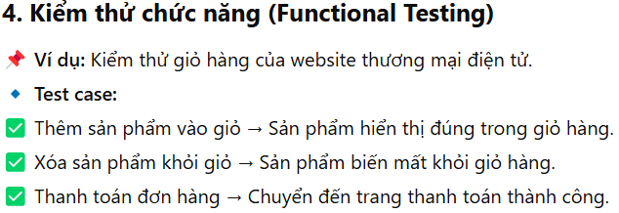
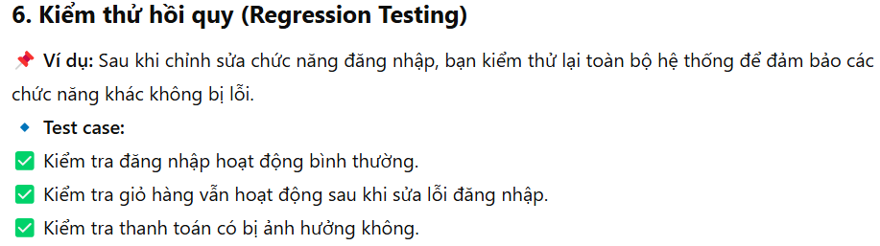

Benefits of manual over automation testing: faster + more cost-effective to run a manual test for applications/features that only need to be tested once. Can be more accurate when do UI testing because you are experiencing as an end-user.

Functional testing | Nonfunctional testing
- based on requirement/ specification.  - test functionality of an application.  - focus on input and output of system  - include Unit testing and Application testing | - based on customer expectations + performance requirements.  - test behavior of application.  - focus on end-user’s experience while using app.  - focus on how a system/app performs in different scenarios.  - include performance testing, load testing, security testing

Bug: kind of error, failure or unexpected response that prevents a software/app from functioning as expected.

CAREER GOAL:
- I have an interest in learning and progressing in this field and I feel that the opportunity of collaborate with your company will be great for my development. Also, I wanna be a valuable contribution to your team while growing myself in this environment. I hope to gain more experience in this field and like, after 3-5 years, I can mentor and help people who are new to this.

Write testcase for a pen:
Title: Test the pen by writing on a paper
Description / Scenario: A person using this pen should be able to use it to write on the paper.
Precondition: User must have a pen that has ink in it and a piece of paper.
Assumption: User knows how to write.
Test Steps:
- Pick up a pen
- Take a piece of paper
- Write a list of names on the piece of paper.
Expected Results: The paper now has a list of names on itself.

Test management tools used before: Jira; store information on how to carry out a testing, to plan out the testing activities and to log the status of testing activities.

Postitive testing vs Negative testing:

Agile methodology: The Agile Methodology is an iterative approach (pp tiếp cận lặp đi lặp lại) to project management. It seeks continuous delivery of working software created in rapid iterations. It involves constant collaboration with stakeholders and continuous improvement at each stage.
The phases are requirements, design, development, testing, deployment, and maintenance. In Agile methodology, different phases can be worked on concurrently.

INTERVIEW TẠI CÔNG TY TSB:

1/ Giới thiệu bản thân, kinh nghiệm cũ, hoạt động sau tốt nghiệp…
2/ Đã tìm hiểu được những gì về công ty…
3/ Về vị trí QA TESTER, biết được những gì…
4/ Các model trong SDLC; các phase trong từng loại model…
5/ Trong trường hợp có 1 bug mà DEV cho rằng đó không phải là lỗi thì xử lí như nào?
6/ Các level của software testing?
….

